CSE 112, Networked Life
Prof. Michael Kearns
MIDTERM SOLUTIONS
Thursday March 2, 2006

NAME: ___________________________________

PENN ID: __________________________________

Exam Score:

Problem 1: __________/10

Problem 2: __________/15

Problem 3: __________/12

Problem 4: __________/15

Problem 5: __________/10

Problem 6: __________/10

Problem 7: __________/8

Problem 8: __________/8

Problem 9: __________/12

TOTAL: ____________/100

1. Zipf’s Law and the Power Law Distribution (10 points)

a. (6 points) What is Zipf’s law? How is it related to power law distribution?

Zipf’s law states that the rank of an event is inversely proportional to its frequency. In other words, the r^{th} most frequent event occurs with a frequency proportional to 1/r.

Power law distributions have the form p(n) ∝ 1/n^{α} . Hence, Zipf’s law is a power
law distribution with α = 1. The log-log plot of such a distribution is linear.

2 points for correctly stating the law
1 additional point for any precise and correct mathematical definition and graph
2 points for stating that it belongs to the family of power law distributions
1 additional point for stating that alpha = 1

b. (4 points) Briefly describe a real-world example where Zipf’s law holds.

Points were deducted on a case-by-case basis based on the example given.

One acceptable example is the frequency distribution of words present in a large text corpus. If we rank the words in order of decreasing frequency and plot frequency against rank, we get an instance of Zipf’s law.

Just for reference, a plot of frequency against rank is shown below. Frequencies are estimated from a text corpus with1.8M words. Punctuation marks are removed from the analysis. Also, shown in the same graph is the plot of the function f(r) = C/r where C is a constant. Only top 200 most frequent are plotted to make it more readable. From the graph, it is evident that f(r) (the green line) approximates the actual plot (the red line) quite well.

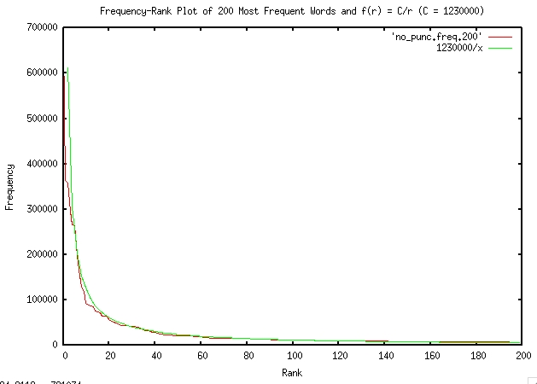

2. Static Properties of Graphs (15 points)

Consider the undirected graph shown in the figure below. Answer following questions with respect to that graph:

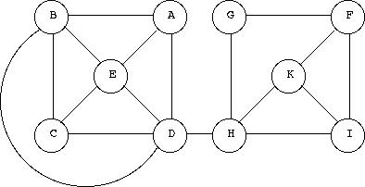

a. (4 points) What are the minimum and maximum degrees in the graph?

G has the minimum degree of 2 and D has the maximum degree of 5.

2 points for minimum degree (no points taken off for not stating the vertex)
2 points for stating the maximum degree

b. (4 points) What is the worst-case diameter? Identify the vertices that are farthest apart (if more than one such pair is possible, then list all of them).

4, A-F, B-F, C-F, B-F

1 point for correctly stating the worst-case diameter
(Correct pair count, points): (4, 3), (3, 2), (2, 1), (1, 1)

c. (4 points) What is the size of the largest clique in the graph? List the vertices in each clique of this size in the graph.

Largest clique size: 4
Clique # 1: A, B, E, D, Clique # 2: B, C, E, D

1 point for stating 4
2 points for identifying one clique correctly
1 additional point for identifying the second clique

d. (3 points) What is the minimum number of edges that could be removed to make the graph unconnected? List these edges.

2 points for stating the minimum number of 1
1 point for stating the edge DH

3. The PageRank Algorithm (12 points)

a. (3 points) Suppose the PageRank algorithm is run on the graph in Figure 1 with all pages starting with the same rank. Which page or pages will have the highest page rank in the network?

3 point for stating A, B, C, D
1 point for stating any subset of {A, B, C, D}

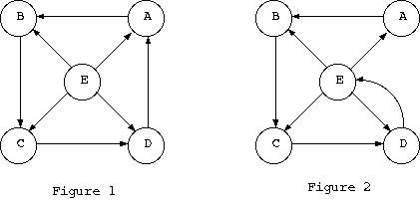

Suppose the network in Figure 1 is modified (by removing the link DA and introducing the new link DE) to produce Figure 2. Answer the following question with reference to Figure 2:

b. (3 points) Pages D and E now form a cycle. If the PageRank algorithm is run again on the new graph, do you expect D and E to have the same page rank? Give reasons in support of your answer.

E gets all of its PR from D and because of the structure of the network, D can’t have any lower PR than E.

2 point for stating yes or just D, if supported by valid arguments
1 point off for stating just E
1 additional point for reason

One acceptable explanation: Let PR_A be the page rank of page A. We have,

PR_A = PR_E/4, PR_B = PR_E / 4 + PR_A = PR_E / 2
PR_C = PR_B + PR_E / 4 = 3 PR_E/4
PR_D = PR_C + PR_E/4 = PR_E

This is not entirely accurate since we have walked through the nodes sequentially ignoring iteration. But using the Page-Rank algorithm given in class, the PR values converge in a small number of iterations with D and E having almost equal page ranks.

One acceptable explanation favoring D over E is when one includes damping coefficient in PR computation (mentioned in the original Page-Rank paper). The PR calculator showed in class takes this into consideration. Using this, the page rank update rules are

PR_A = (1-d) + d * PR_E / 4
PR_B = (1-d) + d * (PR_A + PR_E / 4)
PR_C = (1-d) + d * (PR_E / 4 + PR_B)
PR_D = (1-d) + d * (PR_E / 4 + PR_C)
PR_E = (1-d) + d * PR_D

where d is the damping factor and usually set to 0.85. This leads to slightly higher page rank for D compared to E.

c. (3 points) Which page will now have the lowest page rank? Why?

2 points for stating A
1 additional point for the reason

Site A gets one fourth of the page rank of E. In addition to this contribution, B, C and D have additional PR inputs. Moreover, A receives one fourth the PR of E and so A can’t have higher PR than E. Hence, A has the lowest page rank.

d. (3 points) Which page will now have the highest page rank? Why?

2 point for stating D and E or just D, if supported by valid arguments
1 point off for stating just E
1 additional point for comparing the stated nodes to all other nodes

Arguments are similar to the ones in part (b).

4. Equilibrium in Strategic Interaction (15 points)

a. (5 points) Consider the process of individuals arriving and choosing where to sit in a large auditorium. Briefly discuss the key features of what we might consider an equilibrium of such a social system. Be sure to discuss both individual incentives or desires, and how they do or do not relate to the global outcome.

2 point for stating that nobody is motivated to move to another seat assuming everyone else remains in their seats i.e. nobody can do better by changing his or her seat i.e. unilaterally no one wants to change seats
1 additional point for extra features: e.g. for stating that this need not be a unique equilibrium or for stating that the achieved equilibrium need not be the best possible

2 points for valid relation between individual incentive and global outcome e.g. showing using specific examples of individual desires that some global outcome may not satisfy everyone’s individual desires, etc.

b. (5 points) Briefly discuss the phenomenon and dynamics known as the Market for Lemons.

For full credit, the answer should mention the sequence: There is an initial asymmetry of information and hence buyer doesn’t have full information about quality and hence the seller can pass on lower quality goods. Thus the buyer considers only average quality and price is offered accordingly. This drives away good quality products as they are under priced. As the average offered price makes a good deal for lemon dealers, the market is flooded with more lemons. Eventually, the market falls apart.

c. (5 points) Consider our Behavioral Graph Coloring experiments under individual incentives --- that is, the payment scheme where individual subjects were paid as long as they did not participate in any coloring conflicts, regardless of the global outcome. Are proper colorings of the graph equilibria in this system? Do equilibria that are not proper colorings exist? Briefly justify your answer.

2 points for recognizing that proper coloring is an equilibrium
2 points for stating that equilibrium in non-proper coloring is also possible
1 point for a valid explanation

One acceptable example: Consider a linear chain with 4 nodes and 2 colors (Red and Blue) and current coloring Red-Blue-Blue-Red. Nodes are just trying to minimize number of conflicts locally. In such a case, there is no incentive for anyone to change color since changing color does not lead to reduction in number of local conflicts.

5. Clustering (10 points)

What is the clustering coefficient of each node in the following graph? What is the (average) clustering coefficient of the graph? (You may leave your answers as fractions.)

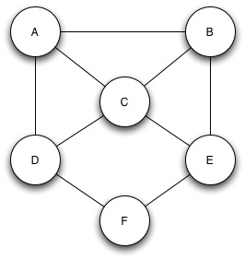

A: 2/3 B: 2/3 C: 1/2

D: 1/3 E: 1/3 F: 0

Graph clustering coefficient: 5/12

1.5 points deducted for each wrong answer, final score rounded down if only 1 part wrong, up otherwise (i.e. 8 points for 1 wrong, 6 for 3 wrong).

6. Generative Graph Models and Distributed Graph Coloring (10 points)

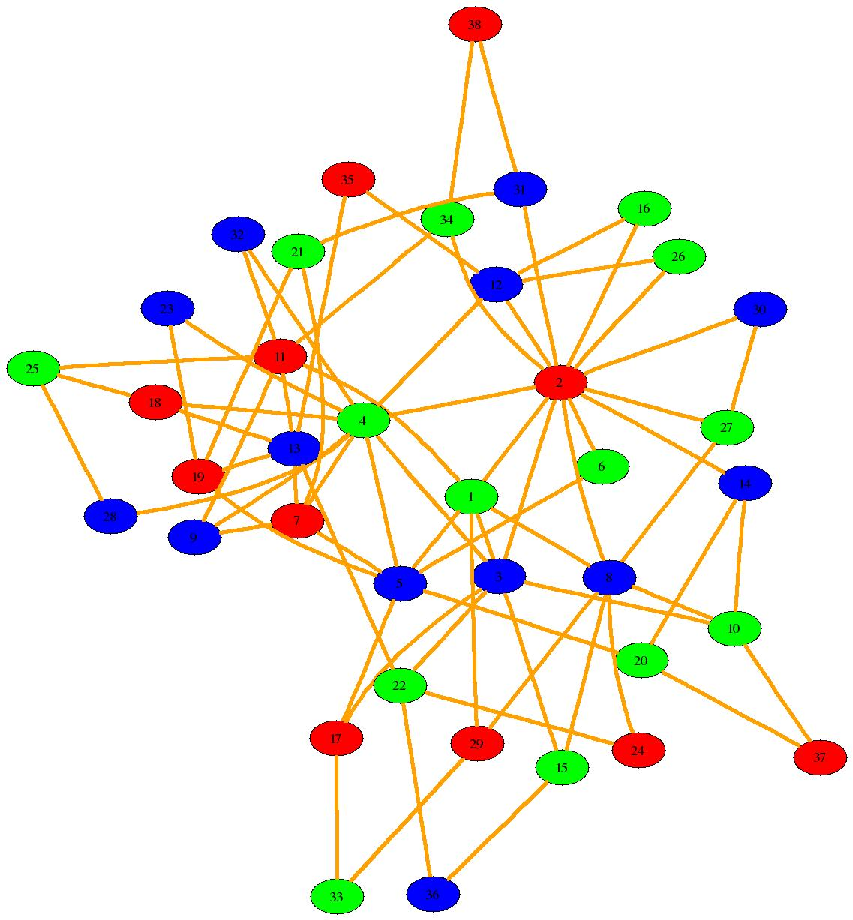
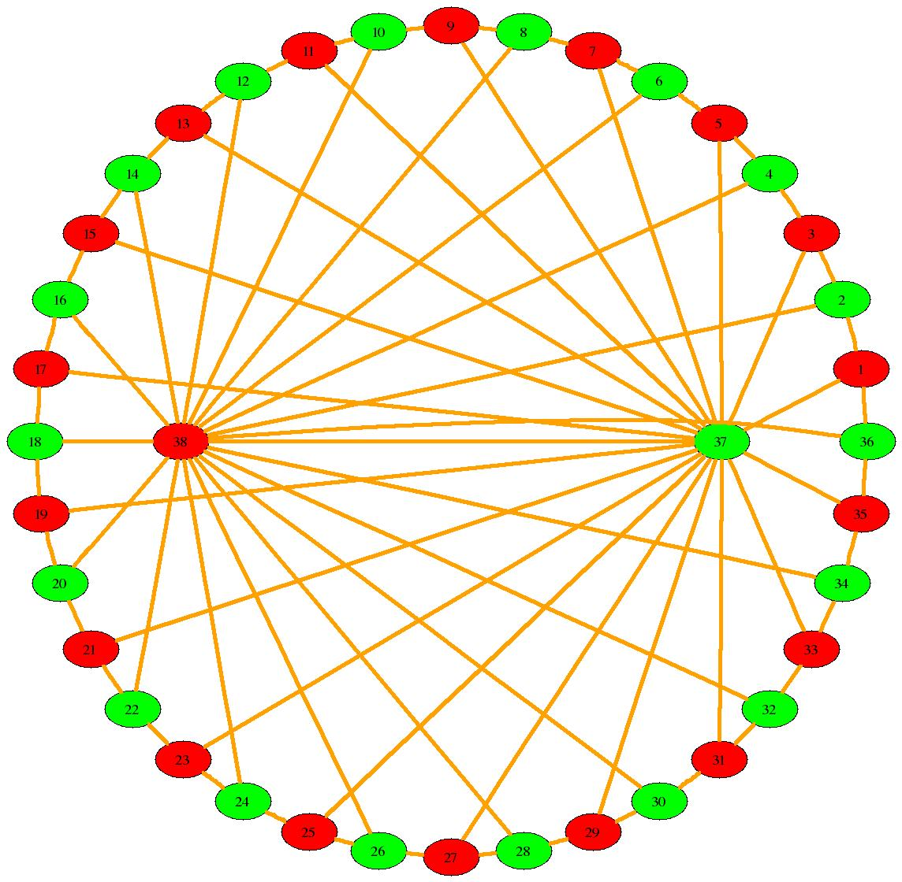
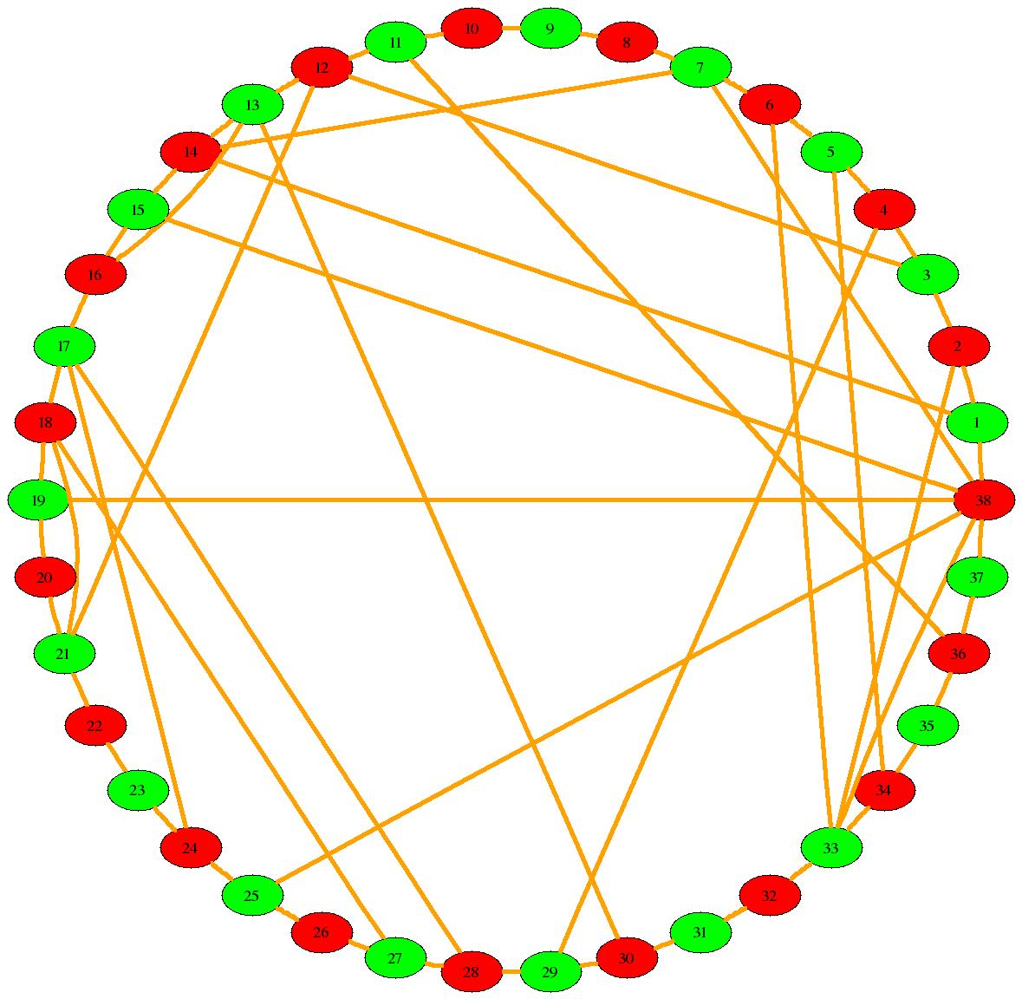
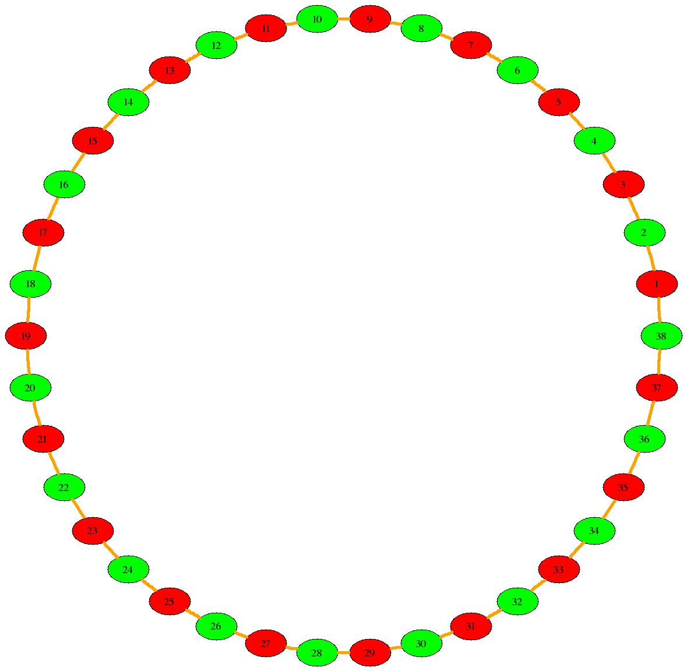
(A) (B) (C) (D)

This problem considers the four graphs (A)-(D) shown above.

a. (6 points) For the graphs (A) and (B), describe the statistical model you think was used to generate these graphs. Be as precise as you can about the specific steps in the generation process. If the model you have in mind has a name, feel free to give it, but be sure to describe the process itself as well.

(A) First, a (deterministic) cycle of 38 nodes was generated. Then twenty chords were added randomly in such a way that the chromatic number of the graph would never increase to more than 2.

Common point deductions for A:
-1 for not describing the process in such a way that some randomness is involved
-1 for not mentioning that we start with some underlying structure (cycle)
-1 for not mentioning that the chords were selected in such a way that the graph would maintain a chromatic number of 2

Answers describing something like the Kleinberg model were accepted, but -1 for not explaining why the graph is still 2-colorable, and -2 for not actually describing the model.

(B) This graph was generated by preferential attachment with a parameter of 2. First three nodes were created and three edges added to connect these nodes. One by one the rest of the nodes were added. Each time a node was added, it was connected to 2 pre-existing nodes in such a way that the probability of connecting to any given node was proportional to the current degree of the node.

Common point deductions for graph B:
-2 for stating it is preferential attachment but not giving an explanation
-1 for explicitly stating it is preferential attachment with parameter 3 (or higher)
-2 for stating and describing one of the Erdos-Renyi models (does not explain the existence of connectors)

b. (4 points) Suppose that human subjects played distributed graph coloring on these graphs, seeing only their own color choice and those of their neighbors, and no other information. Write down what you think would be the order of difficulty of coloring these four graphs, from easiest to hardest. Briefly justify your answer by describing what properties of the graphs would make them easier or harder for human subjects to color.

One acceptable answer is, for example, C, A, B, D.

C is the easiest graph to color due to the presence of connectors. The connectors in the graph will see that they have many neighbors and remain stubborn about their color choices causing the other nodes to choose colors accordingly.

A is easy because each node has a relatively small degree and the chords will stop conflicts from circulating endlessly.

B is difficult because there is no regular underlying structure and high variance in the number of neighbors each vertex has.

D is the hardest in low information because conflicts can circulate at opposite sides of the graph and take a long time to meet and be resolved.

Full points rewarded for any well-justified ordering. Points deducted on a case-by-case basis for unclear justifications or false statements.

No points given for stating an ordering with no explanation.

7. Random Connectivity Models (8 points)

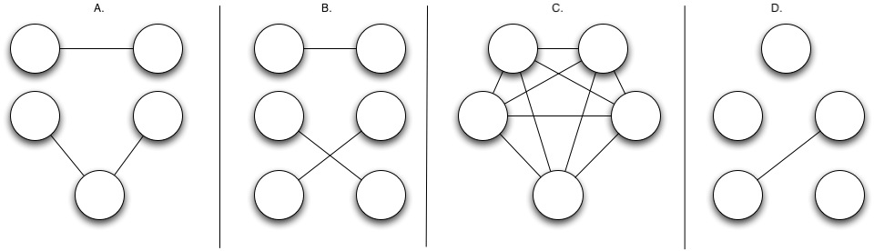

a. (4 points) Which one of the four graphs shown above is most likely to have been generated by a G(N, p) model with N=5 and p=0.3? Why?

Graph (A) is the graph most likely to have been generated by this G(N,p) model.

A graph generated by the G(N,p) model must have N vertices, so our choice is limited to (A), (C), and (D). With the G(N,p) model we expect to see about N(N-1)/2 * p = 3 edges. Alternately, we expect to see an average degree of about (N-1) * p = 1.2. Graph (A) displays both of these properties.

Common point deductions:
-4 for choosing either B or C
-3 for saying both A and B because they have the correct number of edges
-3 for choosing D with plausible reasoning
-2 for choosing A but not stating reasonable justification

b. (4 points) Which of the graphs (if any) could not possibly have been generated by such a model? Why?

Graph (B) could not possibly have been generated by the G(N,p) model with N=5 because it has 6 vertices. While it is highly unlikely that graph (C) would be generated by such a model, it is technically possible.

Common point deductions:
-4 for not listing B
-2 for listing B without giving a reason
-2 for listing one of the other graphs in addition to B
-3 for stating that all of the graphs could have been generated by some G(N,p) model (this is true, but does not answer the question)
8. Monotone Properties of Graphs (8 points)

State whether each property of graphs listed below is monotone.

Two points were given for each correct answer, no explanation required.

a. (2 points) chromatic number greater than 3

Monotone. If at least three colors are needed to color a graph and additional edges are added the chromatic number can only increase.

b. (2 points) existence of a connected component of size at least 10

Monotone. A connected component cannot become unconnected when more edges are added, so the connected component of size 10 will never become smaller.

c. (2 points) diameter less than 5

The answer to part (C) actually depends on how diameter is defined on unconnected graphs. If the diameter of an unconnected graph is defined as infinity, then the property is monotone. If it is defined as the maximum shortest path length between two nodes for which a directed path exists, then the property is not monotone since adding an edge can merge two connected components and thus increase the diameter.

As a result, no points were deducted for this problem.

d. (2 points) clustering coefficient greater than 0.5

Not monotone. Adding edges to a graph can result in the graph becoming less clustered.
9. Search in Social Networks (12 points)

Recall that in Kleinberg's model of navigation in social networks there is a parameter r governing how far away long-distance connections will tend to be, with large values of r indicating a bias towards more local connections. Moreover, rapid search is possible in Kleinberg’s model only when this parameter r takes on values very close to 2.

a. (4 points) What causes search to be difficult at smaller values of r?

When r is small, there is no bias for local connections. Many long distance connections will exist, but without knowledge of the entire network it will not be clear which links will get to the target fastest. Long distance connections might be useful for getting roughly in the vicinity of the target, but a chain of local connections will be necessary in order to reach the target in the end.

Common point deductions:
-1 for stating that no local connections will exist in this model (all nodes are still connected to their immediate neighbors)
-1 for stating irrelevant facts about clustering, degree, etc. (-2 for many irrelevant facts)

Additional logical errors or statements of false facts are judged on a case-by-case basis.

b. (4 points) What causes search to be difficult at larger values of r?

At larger values of r, there will be a heavy bias for local connections and very few long distance connections will exist. This will result in a graph with a very high diameter, so if the target vertex chosen is far away, a short path between the initial node and the target may not even exist.

Common point deductions:
-1 for not mentioning (at least implicitly) that short paths may not exist for some pairs of nodes
-1 for stating irrelevant facts (-2 for many irrelevant facts)

-3 for mixing up small and large values of r (the difference is stated in the problem intro!)

Additional logical errors or statements of false facts are judged on a case-by-case basis.

c. (4 points) Briefly describe how Kleinberg's explanation of efficient navigation differs from the attribute-based explanation of Watts, Dodds, and Newman.

Kleinberg’s model of search focuses on a single lattice-based notion of distance between nodes. The Watts, Dodds, and Newman model instead defines a multi-dimensional measure of distance between nodes/people based on people’s attributes. In the WDN model, each person has vector of attributes relating to their occupation, geographical location, interests, and so on. Distance between two people is then defined as the shortest distance between any of their attributes.

The WDN model is generally easier to navigate and more efficient for search because it does not require the precise parameter tuning that is necessary in order to make search possible in Kleinberg’s model.

Common point deductions:
-3 for not mentioning and describing the multi-dimensional aspect of Watts model
-1 for not mentioning that the Watts model does not require such fine parameter tuning or at least that efficient search is possible on these networks

