Thank you for participating in today’s experiments. This handout contains important information regarding the rules and procedures of this experiment. Please listen carefully and follow the directions provided here, as well as the oral instructions given by the proctors of this experiment.

Please note that compensation is contingent upon adherence to the guidelines of the experiment, as well as passing a simple quiz designed to ensure understanding of the problem. Please do not hesitate to raise your hand if you have any questions.

The Graph Coloring Problem

During the experiment, you will be solving the graph coloring problem. The following sections will introduce the necessary concepts.

I. Graphs

A graph (or network) consists of nodes and edges. Referring to Figure I, the nodes are the circles, and the edges are the lines that connect the circles. In our experiments, each of you will be identified with a node (labeled "YOU" in the example of Figure I).

The nodes that you are directly connected to by an edge are called your neighbors. In the example of Figure I, these are the nodes shown as dark circles connected to the node labeled "YOU". The degree of a node is its number of neighbors. Thus in Figure I your degree is 6. The understanding of these concepts will be essential in your successful participation in today’s experiment.

Figure I (below)
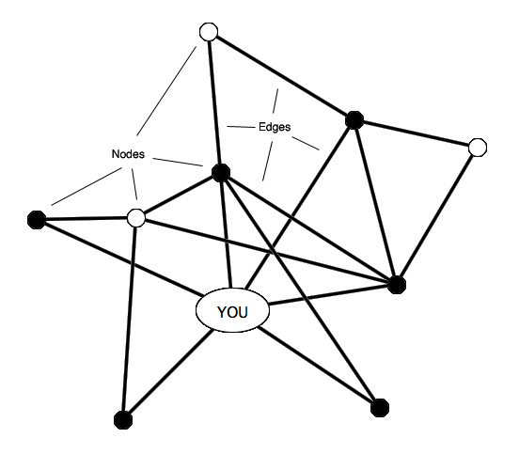

II. Coloring

In today’s experiment, participants will be choosing colors to their respective nodes. Their goal will be to successfully color several given graphs. A graph is successfully colored if every node is assigned a different color than all of its neighbors.

Figure 2 (below)
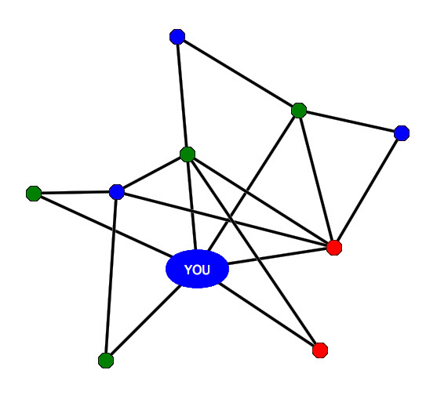

Figure 2 depicts a successfully colored graph. You can check that every node’s chosen color is different from its neighbors’ assigned colors. This is not just true for the node labeled "YOU", but throughout the entire graph.

However, in the example of Figure 3, we see that your current node has the same color (red) as two of your neighbors (also red). Hence, this graph has NOT been successfully colored.

FIGURE 3 (below)
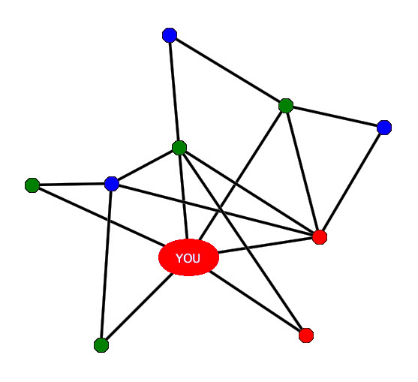

EXPERIMENTAL LAYOUT

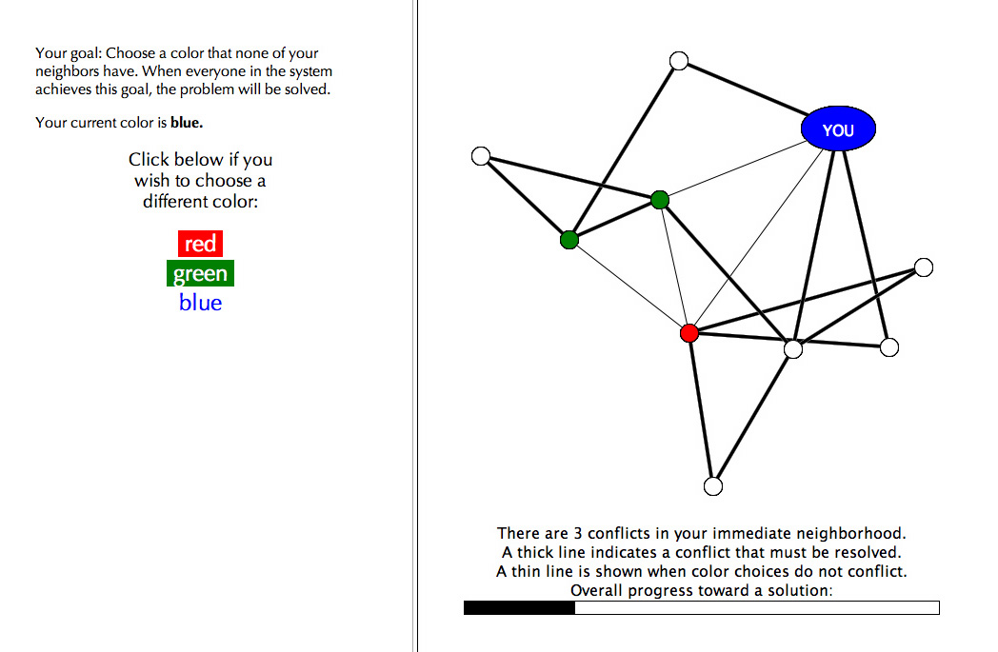

Above is the experimental layout. The left panel of the system allows you to view and change your current color while the right panel gives information regarding the status of the collective problem. Note that your node is clearly labeled "YOU". Furthermore, note that some edges are thick (bold) while others are not. Thick edges indicate that YOU have a color conflict with that specific neighbor. Thin edges indicate that your color does not conflict with the one chosen by that specific neighbor. Finally, the progress bar indicates how close the entire group is to a successful coloring.
INFORMATION CONDITIONS

You will be participating in a series of graph coloring experiments. Varying amounts and types of information will be provided to you and your peers in the right panel of the system.

LOW INFORMATION CONDITION:

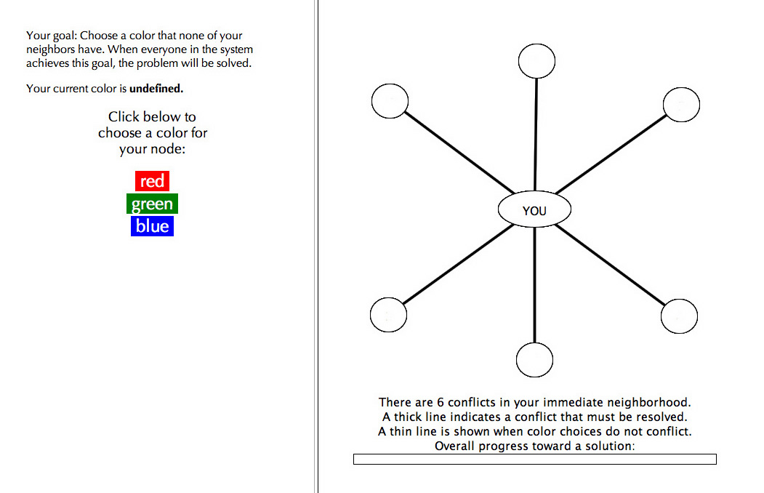

In the low information condition, you will be shown only your own current color and those of your neighbors
MEDIUM INFORMATION CONDITION:
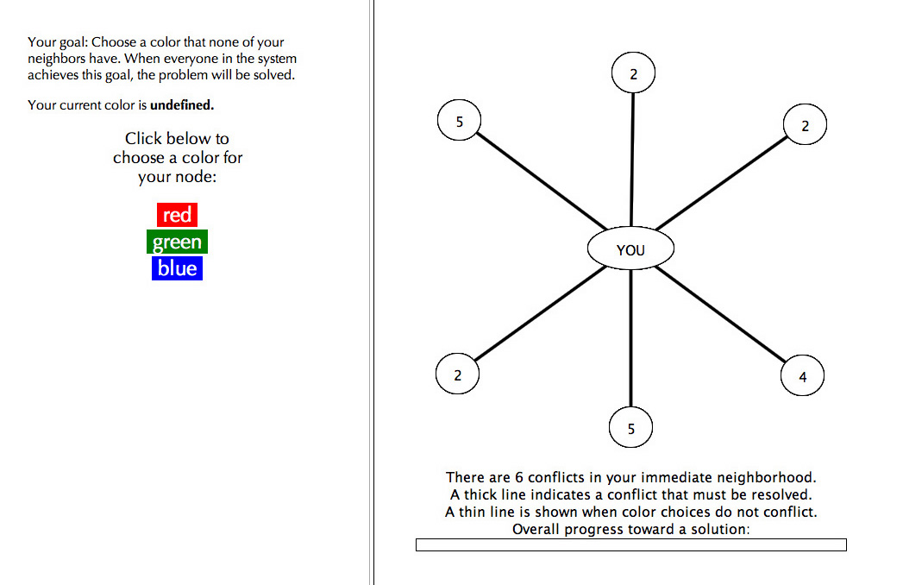

In the medium information condition, you will again be given the color information of your neighbors. However, you will also be given your neighbors’ degree values. Recall that the degree of a node is how many nodes that node is connected to (including you).
HIGH INFORMATION CONDITION:

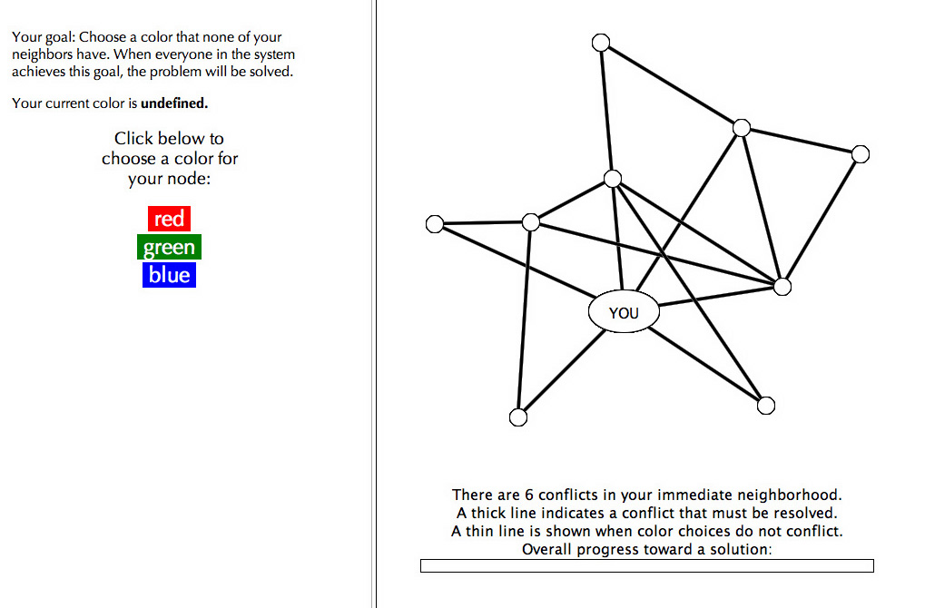

In the high information condition, you will be given node, edge and color information for everyone in the graph.

CONCLUDING REMARKS

In today’s experiment, you and your peers will be attempting to solve 12 graph coloring problems. For each problem you will be given up to 5 minutes to reach a collective solution. In each problem, your node will begin with no color assigned (i.e. your color will initially be undefined). By definition, unassigned nodes conflict with all colors.

You will be given clear instructions on when each portion of the experiments will begin and end. Some important ground rules:

- You are to have absolutely NO interaction with the other participants except through the experimental system. This means absolutely NO talking, gesturing, or other attempts at communication. Your only interactions should be with the system and the proctors.
- You should not use the computers for ANY activity other than the experiments. Do not attempt to open any web pages or applications, read your email, change browser or system settings, etc.
- During periods in which you are choosing not to change your color, or between experiments, please sit quietly and at attention. Do not engage in non-experiment activities such as reading, listening to music, etc.
- Stay in your assigned seat at all times. If you have any questions, raise your hand and ask a proctor.
- Any violations of any of these ground rules will result in immediate dismissal without compensation.

You will now be administered a short quiz to make sure you understand the basics of the graph coloring problem. When you are finished, raise your hand and a proctor will come and check your results. If you fail you will be given a second chance on a similar quiz.

Thank you for your participation today.

