Homework 2
Networked Life (NETS 112)
Fall 2018
Prof Michael Kearns

Posted December 3, 2018. Due in hard-copy format at the final exam on December 17, 2018 at 9AM. Please don’t forget to write your name and staple the pages together.

Collaboration of any kind is NOT permitted on the homework.

Your Name:

Problem 1: ________/15

Problem 2: ________/20

Problem 3: ________/15

Problem 4: ________/15

Problem 5: ________/15

Problem 6: ________/20

TOTAL: _________/100

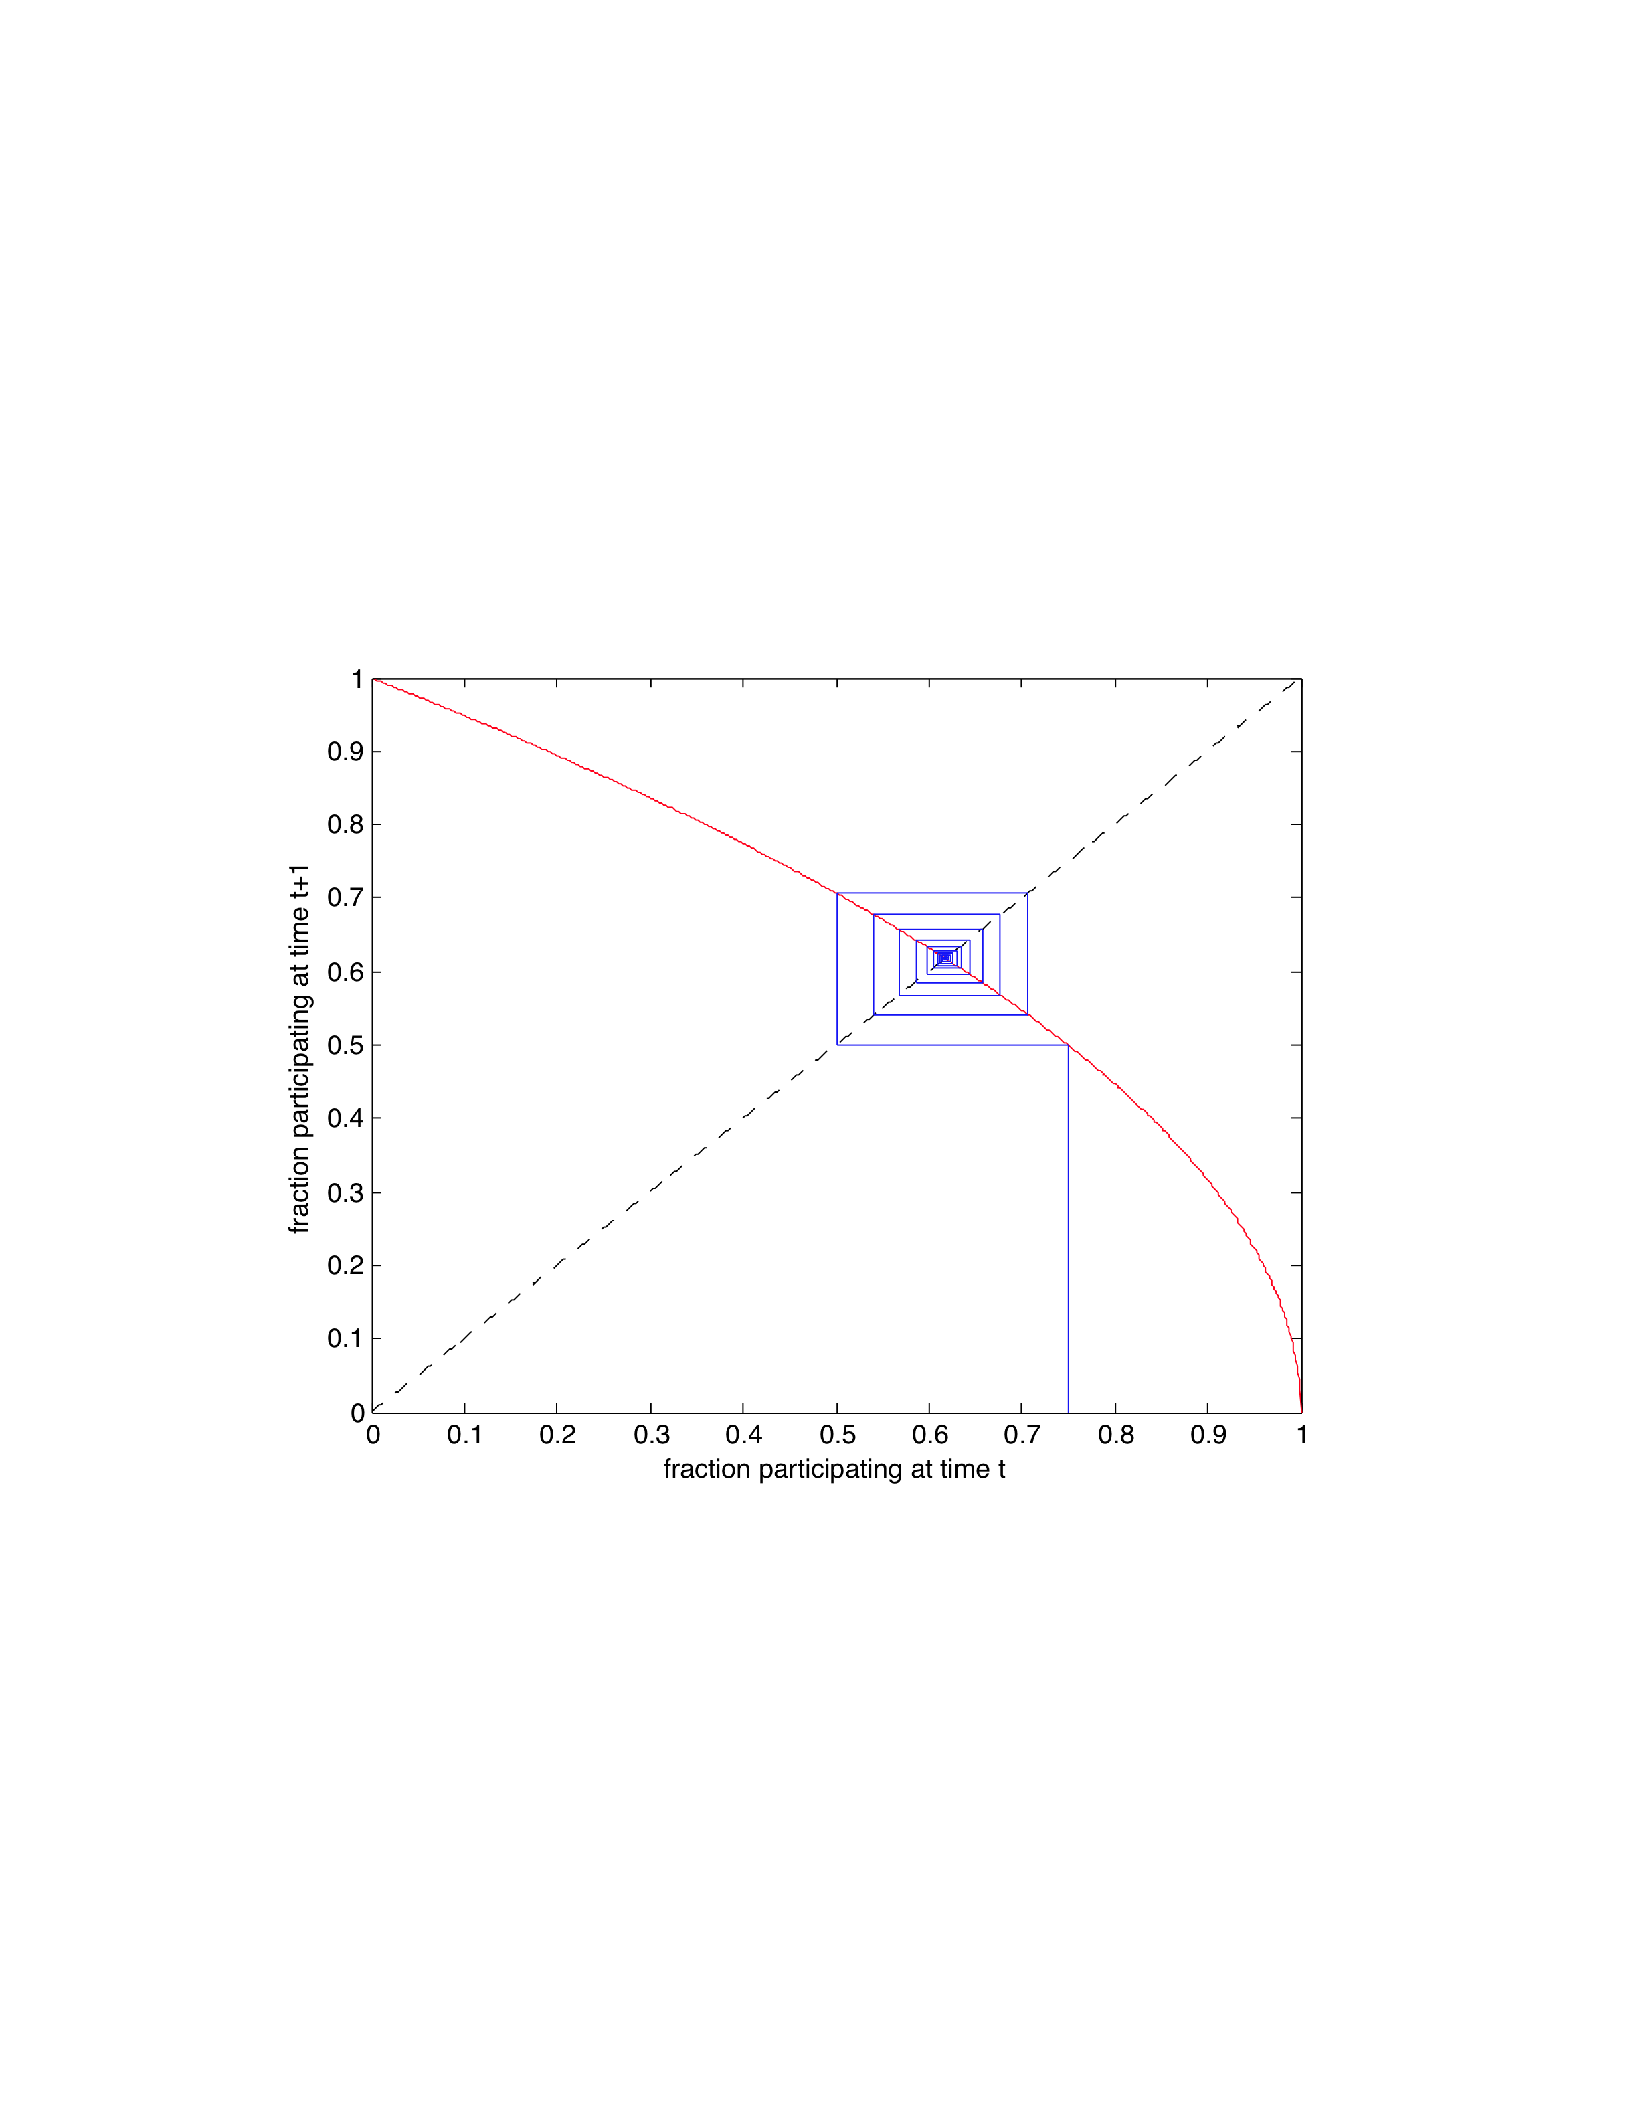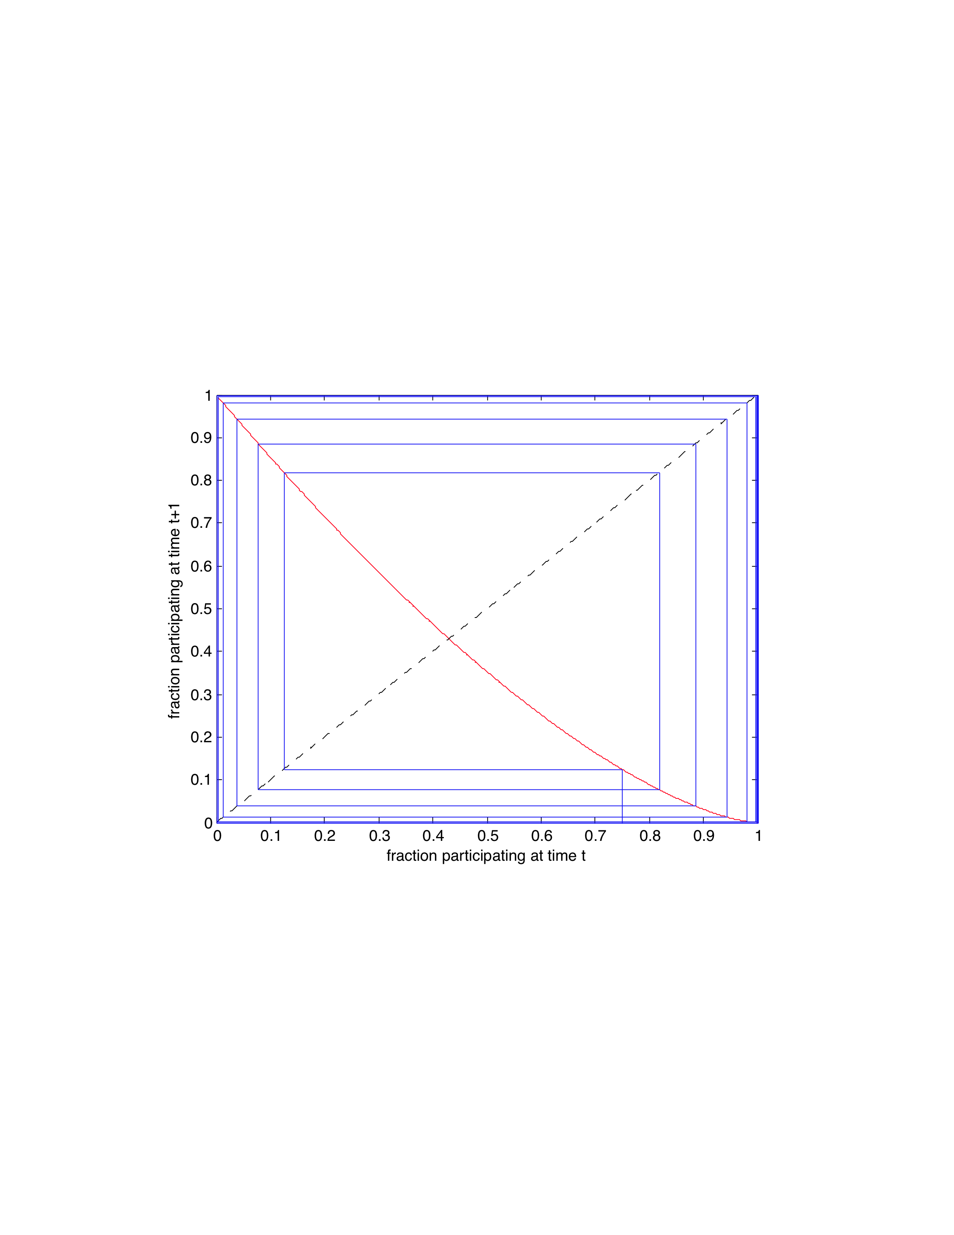
Problem 1 (15 points). The two figures above show, in the red curves, models the amount of collective participation in some activity at time t+1 (y axis) as a function of the amount of participation at time t (x axis). Answer the following questions for each of the two figures. You may clearly annotate the diagrams if it will help clarify your answers.
- How many equilibrium points are there, and are they stable or unstable?

- What will be the limiting behavior of the population if we repeat the process indefinitely (i.e. let t go to infinity?)

- If in part b. you answered differently for the two figures, discuss why you think the limiting behavior is different; and if you answered the same for the two figures, discuss why you think the limiting behavior is the same.

Problem 2 (20 points). Consider networks in which there are two types of individuals/vertices. Red vertices are happy if at least half of their neighbors are also Red, and otherwise are unhappy. Blue vertices are happy if at least half of their neighbors are also Blue, and otherwise are unhappy.

- Draw a connected network in which there are 5 Red vertices and 5 Blue vertices, and the total happiness is maximized.

- Draw a connected network in which there are 5 Red vertices and 5 Blue vertices, and the total happiness is minimized.

- Draw a connected network in which there are 5 Red vertices and 5 Blue vertices, and only the Red vertices are happy.

- Draw a connected network in which there are 5 Red vertices and 5 Blue vertices, and there are exactly 3 happy Red vertices, and exactly 3 happy Blue vertices.

Problem 3 (15 points). Consider a house with N housemates and a shared Wi-Fi network. Each housemate would like to download their favorite content over the network. If housemate i attempts to download b_i bits of content during a specified time period, then the common speed or rate r at which downloads occur for everyone is r = 1/(b_1 + b_2 + … + b_N) (thus the common rate decreases or slows the more demand there is), and the payoff or utility to housemate i is then r times b_i. There is no limit on how large b_i may be --- each housemate may be as greedy as they like.

- Clearly describe the equilibrium of this game. Explain or justify your answer.

- What is the social welfare (i.e. the sum of the utilities of all the housemates) at equilibrium? How does the equilibrium social welfare compare to the maximum social welfare possible (i.e. ignoring equilibrium considerations)?

- Based on your answers to a. and b., is this game similar to or different from the two-road driving game described on page 61 of “The Ethical Algorithm”? Explain your answer.

The remainder of the problems on this homework refer to material/topics covered in the book “The Ethical Algorithm”.

Problem 4 (15 points). Recently there have been a number of instances of “cold case” murders being solved using DNA databases intended for genealogical research:

https://www.nytimes.com/2018/10/15/science/gedmatch-genealogy-cold-cases.html

(You can also find other related discussions and articles online, which you should feel free to read and cite.) In these examples, we can view the criminals as having been “harmed” by the use of the genetic data of their relatives to identify them.

Write a brief essay in which you discuss whether the application of differential privacy would or would not prevent such harms. Be as precise as you can, citing both the definition and properties of differential privacy, and material and examples from the book.

Problem 5 (15 points). Chapter 4 of “The Ethical Algorithm” gives a number of examples (such as online dating sites and navigation apps) in which there is a strategic feedback loop between users, the data they generate, the use of that data to adapt the app, and the subsequent changes to user behavior. It also discusses the implications of the competitive equlibria such feedback looks tend to drive users towards. Pick a real-world example other than those given in the book, and as precisely as you can, describe both the details of the feedback loop in question and the equilibrium being reached (and whether you think it is a “good” or “bad” equilibrium).

Problem 6 (20 points). In the last problem, we’d like to ask you for a little constructive feedback on “The Ethical Algorithm”.

- Pick the section, topic or chapter of the book that you found the most interesting, engaging or entertaining, and briefly describe why.

- Pick the section, topic or chapter of the book that you found the most confusing, boring, or irrelevant, and briefly describe why.

- (Extra Credit) We would very much appreciate any additional free-form feedback you have on the book, whether very high-level (entire chapters or topics), very low-level (particular paragraphs or sentences), or anything in between.

