Homework 1: Networked Life (MKSE 112), Fall 2012, Prof. Michael Kearns
Issued Oct 2, 2011. Due as hardcopy in class Tuesday Oct 16. Remember that collaboration on homework is not permitted. Don’t forget to staple and write your name.
- (40 points) Consider the undirected network shown below.
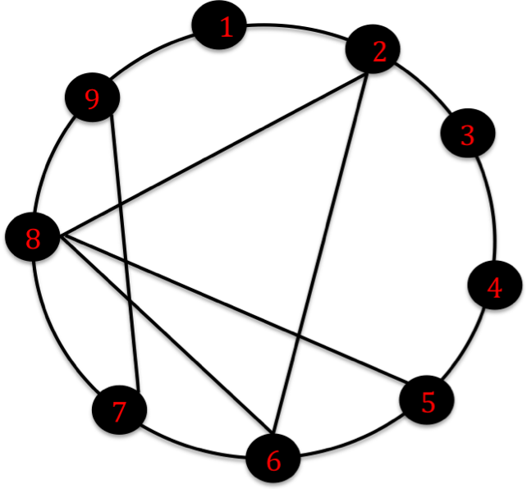
a) (5 points) What are the minimum and maximum degrees in the network?
b) (5 points) What is the worst-case diameter of this network (largest shortest-path distance between any pair of vertices)? Put a “*” next to two vertices whose distance equals the diameter.
c) (15 points) What is the clustering coefficient of the network? What is the overall edge density of the network? Would you consider the clustering coefficient high or low, and why?
d) (15 points) A coloring of a network is an assignment of a color to each vertex such that all pairs of neighboring vertices have different colors. Coloring can be viewed as a problem of social differentiation --- for instance, nobody wants to wear the same outfit as a colleague on a work day, and it’s better if everyone’s cell phone ringtone is different than those of their close friends. On the network above, find a coloring that uses as few distinct colors as possible. Write each vertex’s color next to it.
- (30 points) In this problem, we will consider the directed network given by the web graph --- that is, the network in which the vertices correspond to web sites or pages, and there is a directed edge from page A to page B if there is a hyperlink on page A to page B (there may or may not be a reciprocal link from B to A). In this problem, we will be considering only directed paths --- that is, paths that follow the edges in the ``right direction’’.
- (15 points) Beginning at www.upenn.edu, find the shortest directed path you can that arrives at a web page hosted in the Internet domain of the smallest country (by population) that you can. By a directed path, we mean a sequence of complete URLs such that the page corresponding to each URL contains a link to the page corresponding to the next URL in the sequence. Your path may not contain URLs in the domain of any major social media site or search engine --- i.e. Facebook, Twitter, Google, etc. Write down the full URLs of the web pages along your path. If you like you may give a couple of different paths. You may use any methods you like, including search engines, to find your path, but the path itself must obey the rules specified above. Your path will be graded for its correctness, as well as how short it is and how small the destination country is. To find country-level Internet domains, use the following page:
http://en.wikipedia.org/wiki/List_of_Internet_top-level_domains#Country_code_top-level_domains
To find country populations, use the following:
http://en.wikipedia.org/wiki/List_of_countries_by_population
- (15 points) Discuss how you went about finding your short path(s) above --- what information you used about the pages visited, how you searched locally from each page, what other tools or methods you employed, etc.
- (30 points) In this problem, you are asked to consider your own Facebook neighborhood network. This is the network of connections between your Facebook friends, but excluding yourself and all your connections (you are needed only to identify your friends).
- (15 points) Estimate the edge density of your FB neighborhood network, and describe your methodology and calculations carefully. (Note that the edge density of your FB neighborhood network is the same as your own clustering coefficient.)
- (15 points) Identify a group of at least 10 vertices for which you suspect the clustering of connectivity of that group is much higher than overall edge density computed in Part b). Verify this suspicion numerically, and describe your methodology and calculations carefully. Discuss how you identified this group, and why you think their connectivity is clustered.

